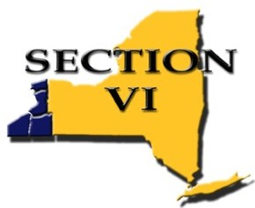

FINANCE COMMITTEE
AGENDA

September 5, 2019 – 12:00pm
Teleconference

WebEx Conferencing Procedure:
Call: 716-558-5555
Meeting number (access code): 731 376 097
Attendee number: press #

Committee Members:
S. Penhollow, Chairman
TBA, Buffalo Representative
A. Gens, CCAA Representative
*V. Dell’Oso, ECIC Representative
J. Contento, NFL Representative
*R. Carberry, NO Representative
*T. Slade, Executive Director
*D. Scholla, Treasurer

- Fund Balance

1.1 Treasurer’s Report

2.0 Old Business

3.0 New Business

3.1 Web-site Fee
3.2 Dues Increase
3.3 Invoice Schools (meals, travel etc..)
3.4 Invoice Schools (meals only)
3.5 Coordination Fees Structure
3.6 Rapid Financial – Debit/ID Cards
3.7 Spring 18-19 Financial Reports

4.0 Good of the Order

